DESIGNATION | QTY | BEST BEFORE | PACKAGING | 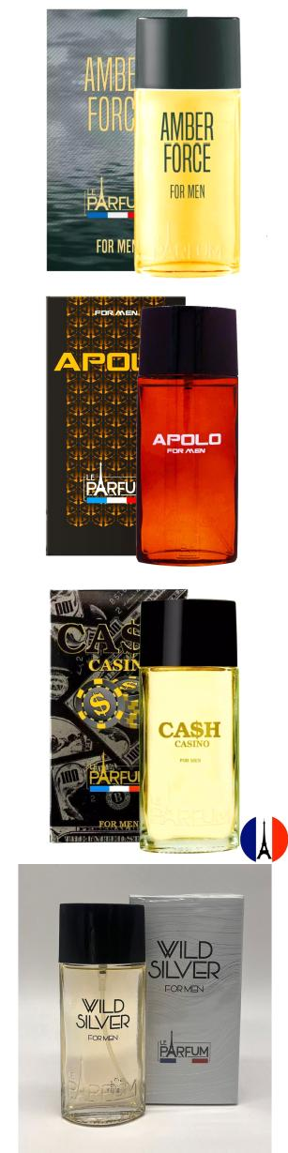  PHOTO
PERFUME AMBER FORCE 75ML (MEN) | 2880 | set/29 | 48
PERFUME APOLO 75ML (MEN) | 2880 | jan/30 | 48
PERFUME CASH CASINO 75ML (MEN) | 2880 | jan/29 | 48
PERFUME WILD SILVER 75ML (MEN) | 2880 | jul/29 | 48
PERFUME FLEUR DE PARIS 75ML (WOMAN) | 2880 | ago/29 | 48 | 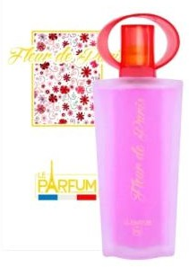

PERFUME VIOLINE 75ML (WOMAN) | 2880 | dez/29 | 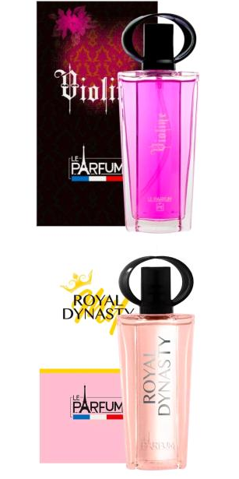  48
PERFUME ROYAL DYNASTY 75ML (WOMAN) | 2880 | fev/30 | 48
PERFUME EPSILON 75ML (WOMAN) | 2880 | dez/29 | 48 | 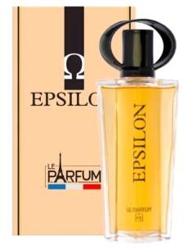
PERFUME HEROIC 75ML (MEN) | 2880 | jan/30 | 48 | 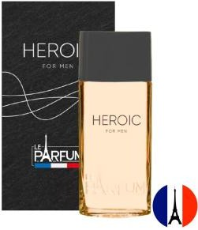
TOTAL | 25G20

